**Handcrafted Haven Brand**

**Logo:**

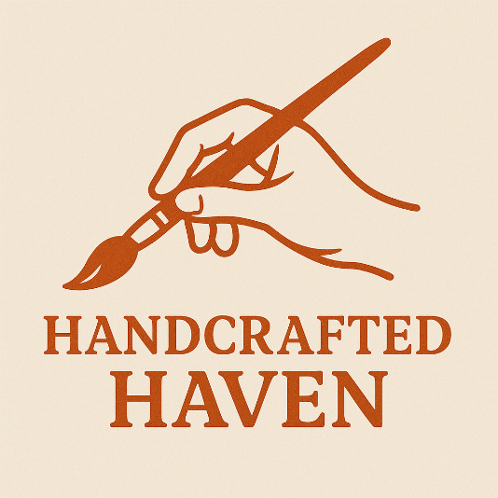

**Colors:**

**1. Primary Color – Burnt Orange**

* **HEX:** #B3511D
* **RGB:** 179, 81, 29
* **Use for:** Logos, primary buttons, headers, highlights.

**2. Background – Soft Clay / Off-White**

* **HEX:** #F3EBDD
* **RGB:** 243, 235, 221
* **Use for:** Page backgrounds, cards, soft sections.

**3. Text – Warm Charcoal**

* **HEX:** #4A3B30
* **RGB:** 74, 59, 48
* **Use for:** Body text, navigation, input labels.

**4. Accent – Sage Green**

* **HEX:** #8A9A5B
* **RGB:** 138, 154, 91
* **Use for:** Secondary buttons, tags, icons, eco/sustainability highlights.

**5. Deep Plum (Optional Contrast Accent)**

* **HEX:** #59354A
* **RGB:** 89, 53, 74
* **Use for:** Hover effects, alternate calls-to-action, footer backgrounds.

**6. Hover / Dark Burnt Orange**

* **HEX:** #8E3D12
* **RGB:** 142, 61, 18
* **Use for:** Button hover, focus states.

**Example Usage Suggestions**

| **Element** | **Color** |
| --- | --- |
| Header background | #F3EBDD |
| Logo / Hero Title | #B3511D |
| Text | #4A3B30 |
| Button (default) | #B3511D |
| Button (hover) | #8E3D12 |
| Tags / Category chips | #8A9A5B |
| Footer background | #59354A |

**Fonts:**

• **Main Header**: Playfair Display – <https://fonts.google.com/specimen/Playfair+Display>

• **Sub-header**: Cormorant Garamond – <https://fonts.google.com/specimen/Cormorant+Garamond>

• **Body Paragraph**: Lato – <https://fonts.google.com/specimen/Lato>

**Wireframes:**

